Vital Monitoring Wrist Strap
V.M.W.S

Group 7
Victoria Balkissoon (Computer Engineering)
Sarmad Doulan (Electrical Engineering)
Kamal El Fagrich (Electrical Engineering)
David Lizzio (Electrical Engineering)

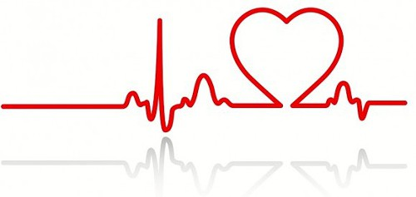

University of Central Florida
EEL4914
Summer 2019

- People participating
The project being proposed is the Vital Monitoring Wrist Strap, a monitoring device that will constantly record the heart rate as a vital function, this data will be made available, through an application, for the caregivers in charge of the subject aiming to relieve their anxiety for their loved ones.
The students working in this project are:
- Victoria Balkissoon (Computer Engineering)
- Sarmad Doulan (Electrical Engineering)
- David Lizzio (Electrical Engineering)
- Kamal El Fagrich (Electrical Engineering)

While there are no sponsors currently involved, the members of the group are the sponsor of this project.

2. Motivation
For many caregivers and family members, having loved-ones including children with heart issues, other medical issues or ones who live alone, it can be difficult to monitor those individuals constantly to ensure that they are alive and are not facing any medical emergencies. One of our group members, Victoria, has seen this firsthand with her grandmother who suffers from several medical issues. Victoria’s mom is constantly in a panic when her mother is not reachable throughout the day and fears that something could have possibly happen to her. Creating a device that would provide constant information about the health status of the individual, through heart rate, temperature, oxygen level would assist people like Victoria’s mom with keeping a watchful eye on their loved-ones, allowing their safety and health to be ensured. We want to create a wearable device that would allow individuals to be monitored by their caregivers and family members from remote locations at all times to ensure their safety. Through this project, we hope to alleviate the anxiety that comes with being a caregiver. Additionally, we hope to maximize the health of patients through providing emergency notifications when their vitals, particularly heart rate, exceeds certain standards so care can be provided as quickly as possible. Moreover, with the evolving world of medicine, we have the desire to contribute to the development of new medical technology.

3. Goals and Aims
The goal of V.M.W.S. is to provide accurate and real-time vital readings of patients wearing the device to individuals (typically their caregivers) at any location. The basis of the proposed device lies in heart rate monitoring alongside other possible vitals such as temperature and oxygen saturation. Alongside conducting the vital readings, the hope is to relay the information to individuals through an easy to use application where all information can be accessed and consolidated for analysis of the patient’s health over time. Additionally, to ensure for greater health benefits, one of the goals for the Vital Monitoring Wrist Strap development is an emergency notification system which would notify caregivers when vitals are out of range such as when the heart rate varies significantly from normal ranges and could possibly be indicating a myocardial infarction (heart attack). The V.M.W.S. should be easy-to-use and be useful for all ages.

The overall product aims of the V.M.W.S. can be summarized in the following list:
- Provide accurate and real-time vital readings such as heart rate and temperature.
- Relay patient vital information to users using an easy-to-use mobile application.
- Store vitals data for each patient so users can access health information overtime for comparison.
- Implement an emergency notification system for indication of out-of-range vital values to maximize the health benefits of the device and assist in ensuring patient safety.
- Create a small, comfortable, safe and easy-to-use daily device that can be worn at all times during most daily activities.
- Device should be durable for long time usage.
- While currently geared toward adults, the device should have the capability to be transferred to a smaller scale for children.

4. Project Description
Objectives:

- Shall produce 1 PCB along with an Android application
- Device will be worn on patient’s choice of wrist
- Device will contain a securing strap to secure wristband to wrist (Velcro)
- Device will have a means to communicate battery life to patient
- Software will display sensor data to care taker
- Software will alert caretaker of anomalies
o Irregular heart beat
o Drastic temperature drops
o Irregular oximeter readings

Software Programs
- Microcontroller will be able to be programmed using Arduino via USB
- Amazon Web Services will be utilized to store data
- Android application will extract information from Amazon Web Services and display to user with a horizontal time scale
- Altium shall be used to design PCB

Engineering Requirements
Requirement Number | Requirement Description
Requirement #1 | Shall produce a product of size 4 x 3 in or less
Requirement #2 | Shall produce a product less than ½ in thickness
Requirement #3 | Shall operate on a rechargeable battery
Requirement #4 | Battery shall be able to be recharged via a 5V external DC power source
Requirement #5 | Sensors shall utilize I2C communication
Requirement #6 | Shall be able to be programmable via USB protocol
Requirement #7 | Device shall contain a 3D printed housing
Requirement #8 | Sensors shall be isolated from patient’s skin
Requirement #9 | Device shall utilize WIFI connection for data relaying
Requirement #10 | Device shall contain a heart rate sensor
Requirement #11 | Device shall contain an oximeter
Requirement #12 | Device shall contain a temperature sensor
Requirement #13 | Microcontroller shall be able to be programmed using Arduino via USB

Design Constraints
Constraint #1 | Battery life may not be sufficient to power MCU for prolonged hours
Constraint #2 | WIFI connection may be intermittent at times (losing packets)
Constraint #3 | HIPAA Security Rule
Constraint #4 | Making the housing small enough to be wearable
Constraint #5 | Sensors may not be totally accurate for vital readings
Constraint #6 | The amount of data that can be logged in the database
Constraint #7 | Placement of sensors
Constraint #8 | Data logging time latency

Standards
Wireless Certificates | SRRC, FCC, CE (RED), IC, NCC, KCC, TELEC (MIC)
Green Certificates | RoHS, REACH
Wireless Communication Standard | 802.11 b/g/n standard
Hardware Communication Standard | USB

5. Medical Overview

Heart rate sensor:
Heart beats are inarguably the most important vital parameter in our heart which can reveal many aspects about the person's health. As it is a pillar in the medical field allowing the professionals to diagnostic a wide range of health situations from chest pain to heart muscle strength.
By adding this sensor to our design, we reinforce the vitality of our project, which also comes with challenges and tradeoffs knowing the boundary set by the health and medical standard and norms.
- State of the art:
The intent as elaborated early in this document is to mimic the heart reading accuracy provided at Hospital rooms, although we will be tracking the heart rate optically versus electrical techniques used in ECG(Electrocardiography) where a few electrodes, usually four (see Figure 1), are to be attached to the patient’s chest and the pattern of heart beats is recorded in form of a graph (see Figure 2). This is still the core concept of the heart rate sensor.
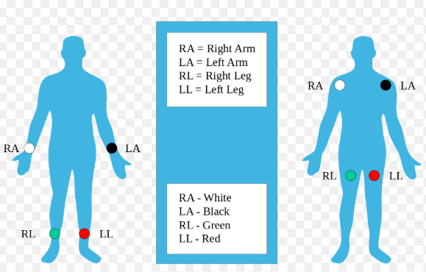
Figure 1

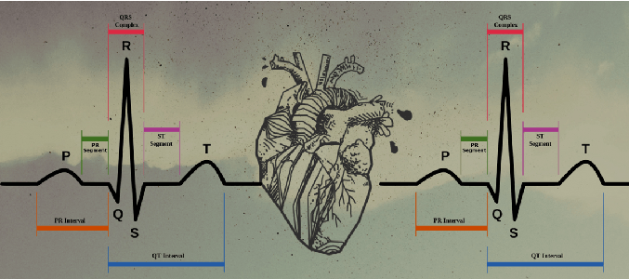
Figure 2

This type of measurement illustrated above, are electrical signals generated due to contraction and relaxation of the heart ventricle muscles where a peak in the signal indicates a heart beats and the number of peaks occurring in a minute are counted to generate the bpm number.

- V.M.W.S OPTICAL SENSOR;
The technique we will be using is known as PPG (Photoplethysmography), which will get us to our goal with less trade off maintaining a range of accuracy accepted for a caregiver to interpret according to case by case basis in the light off the set of standards called for by the health professionals.
This method works by projecting a beam of light onto the blood flow under the wrist’s skin and measuring the difference between scattering light, which changes between heart beats. This change is processed by a well-developed algorithm and digital signal processing to yield a bpm number. Figure 3 shows the overall idea.

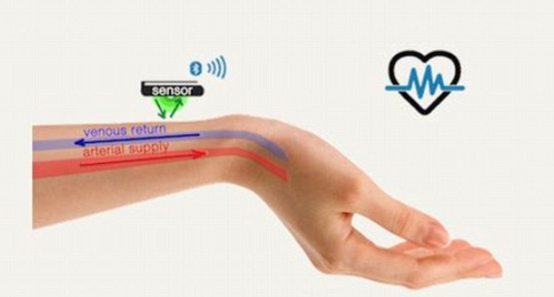
Figure 3

Oximeter:
This is a feature that imposes its vitality at different levels especially in our V.M.W.S where the constraints of the medical field standards set the priorities of our design as we lay out in our strategy and implementation. We will incorporate an Oximeter to our V.M.W.S to track the oxygen saturation. Again, we are aiming for a very tedious task that will surely bring the convenience of use and the accuracy called for by the state of the art.

- Medical definition and recommendation:
Oxygen saturation levels measure the degree to which the Hemoglobin contained in the red blood cells (Erythrocytes) has bonded with oxygen molecules. As of today, technology offers two main methods to assess oxygen saturation in the blood which are Arterial blood gases ABG and Pulsatile oxygen. Normally, more than 89 percent of the blood should be carrying oxygen in order to keep the cells healthy and the body fully functioning. When a person’s blood oxygen saturation level drops below normal, this could lead to serious complications.

The table below illustrates the importance of monitoring this vital parameter:
Table 1
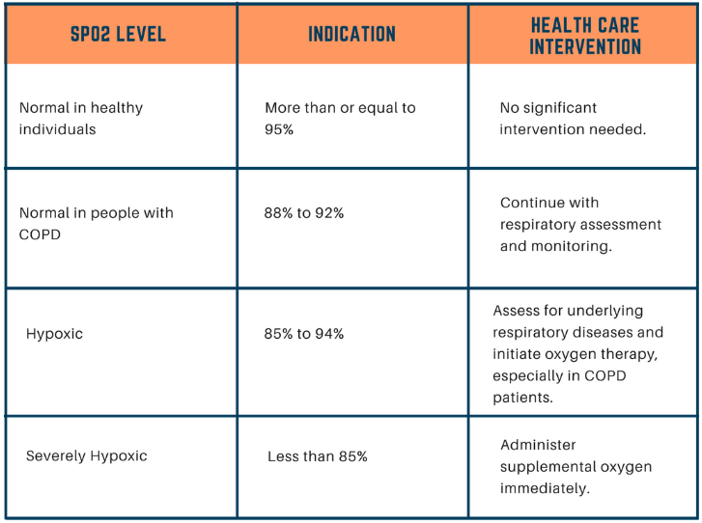
The continuous monitoring of this vital parameter will be achievable in our V.M.W.S using a Pulse oximeter that has the optical ability to emit red and infrared light through a relatively transparent portion of skin. The principal of this technology is that oxygenated hemoglobin can absorb more infrared light allowing more red light to pass through while the deoxygenated absorbs more red light. Using the technique, we could compute the ratio leading to an adequate reading of the oxygen saturation in the blood.

Temperature Sensor:
Although the incorporation of this type of sensor did not resonate well in the market, due to the accuracy challenges, we choose to take on the challenge knowing that it is an extra vital metric to This will bring extra assurance to the caretaker. We hope that we will successfully relay the body temperature taking in consideration that measuring the skin temperature, which is a few degrees Celsius less than that of body temperature. Our V.M.W.S design will consist, essentially of an improved version that will compensate for the ambient temperatures otherwise we will only use it as a reference only and not for alarming medical staff or the caregiver.

6. Block Diagram
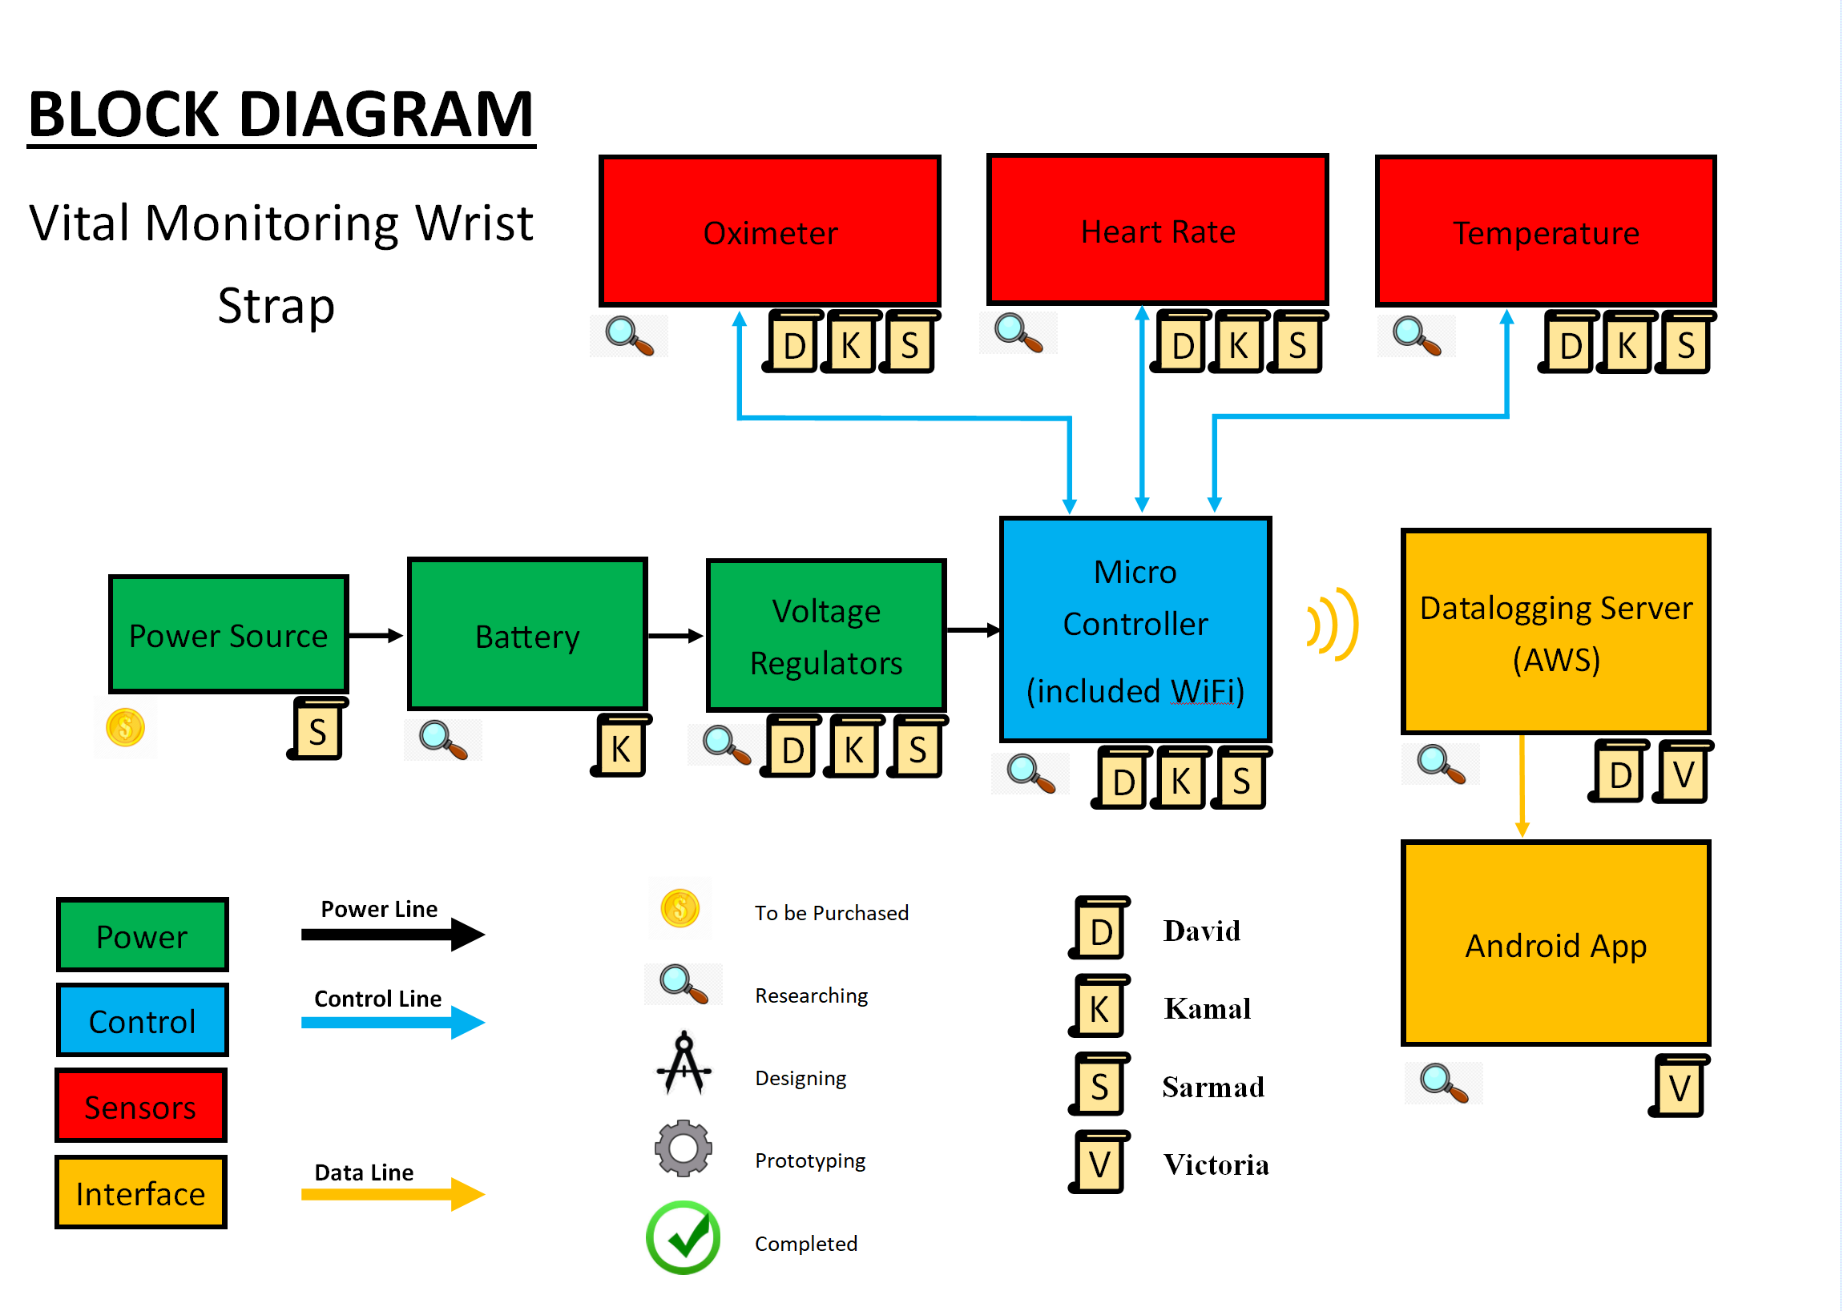
Figure 4

As it shows in the block diagram (Figure 4), we will use three sensors in our Vital Monitoring Wrist Strap. The sensors connected to a Microcontroller which is powered by a battery that is connected to a voltage regulator to regulate the voltage level. The first sensor is the Oximeter, which will be used to measure the oxygen level (Saturation) of the blood. So, it should tell how well oxygen is being sent to body parts. The sensor will send a light then compare how much red light and infrared is absorbed by the blood.

The second sensor we will use is a Heart Rate sensor to measure the heart rate. It works by measuring the electrical pulse by shining light into the skin then measuring the light that scattered by blood flow. So, the amount of light absorbed depends on the blood volume in the tissue. The sensor output will be in a form of an electrical signal and it’s proportional to the rate of heart beat.

The last sensor that our Vital Monitoring Wrist Strap will include is a temperature sensor. It will measure the temperature on the skins surface by converting thermal energy into electrical signal. The microcontroller will send these three different features to the data logging server which will be Amazon Web Services through the WiFi. David will be the lead for the user interface design due to his prior experience in the area. David, Kamal and Sarmad will work to find what will be the best sensors and microcontroller that will fit into our project. Victoria will work on application’s backend algorithm. Also, Victoria will help in the integration process between software and hardware to communicate and synchronize with the Android application.

7. Software Logic Flowchart
The flowchart on the proceeding page (Figure 5) displays the basis behind the logic involved in the software for this project. Each shape in the flowchart represents a different concept behind the logic. The oval represents the start of the processing of information. In this case, it is when the patient is wearing the wrist strap and it is on and functioning. This would allow for information to be gathered by the sensors that will be further processed by actual software. The rhombus shape signifies input and output into the system. The first rhombus after the oval illustrates input into our system as the vitals will be transmitted from the wrist strap to a database. The second rhombus at the bottom of the figure represents output which in this case is the emergency notification that will be outputted by the mobile application if the vitals recorded are out of range. The data is processed by the application as indicated by the green rectangle and compared to standard values that will be coded into the application. The decision of whether an emergency notification needs to be outputted is the final step of processing before it goes back to the top and repeats the process again. The diamond represents making a decision in the flowchart.

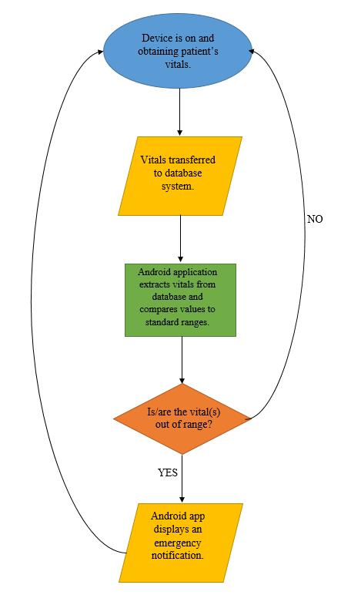
Figure 5

8. House of Quality
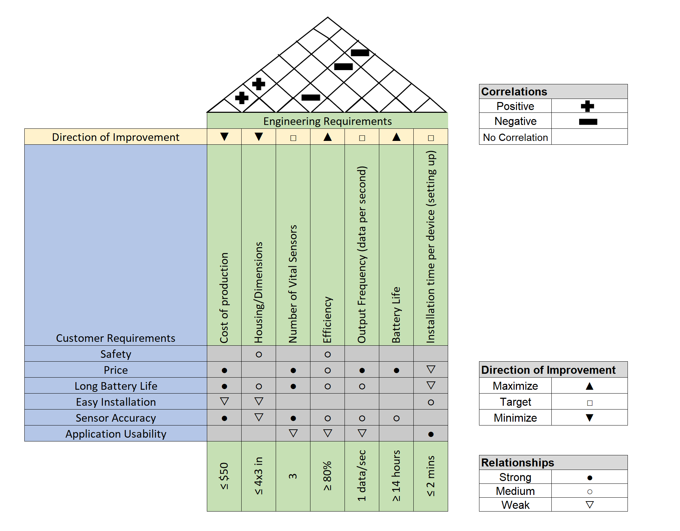
Figure 6
The House of Quality above (Figure 6) depicts the team’s product development plan in unison with the customer requirements. The engineering requirements set a basis for which the team must design a product to fit the customer's desires in an appropriate manner. The left side of the chart, depicted in blue, show the requirements that the customer deems necessary for a product. The green sections of the chart depict engineering requirements for which the team must measure and execute upon for the final product. The ‘roof’ of the chart shows the correlations between different engineering requirements, which is necessary to see how changing one requirement can affect the rest of the project. For example, if the customer desires more Vital Sensors, then the efficiency of the product will decrease instead of staying at the ‘target’ sensor quantity that engineering and the customer had originally agreed upon (3 sensors). Not only does efficiency decrease, but the battery life and installation time per device also gets negatively impacted.

9. Budget and Financing
Our project will be financed by the team members. The project cost will be divided among the four members.

Estimated Budget
Item (number) | Cost
Housing (1) | $ 25.00
Oximeter/Heart Rate Sensor (1) | $ 8.00
Temperature Sensor (1) | $ 5.00
Switching voltage regulator (3.3V) | $8.00
Microcontroller | $10.00
PCB (3) | $ 150.00
Power supply (1) | $ 5.00
Adafruit IO Plus (7 months) | $ 70.00
Wires and components | $50.00
Documentation printing | $50.00
Rechargeable Battery | $50.00
Total | $ 431.00
Cost per member | $ 107.75

10. Milestones

Senior Design I Milestones

Week # | Date | Activity
4 | May 27 | Starting our draft papers
6 | June 4 | Start the 30 pages writing
9 | June 25 | 15 pages should be completed  -  Start breadboarding
13 | July 23 | All 30 pages should be completed  -  Critical functions completed  -  Start PCB design
14 | July 30 | Turning the complete papers in

Senior Design II Milestones

Week # | Date | Activity
1 | August 26 | First meeting at Fall
2 | September 2 | Ordering the SMD parts and PCB boards
4 | September 16 | Soldering the components and test each one individually
7 | October 7 | Assembling the parts and build the projects
13 | November 18 | Test the finished projects
Presentation week |  | Final presentation

